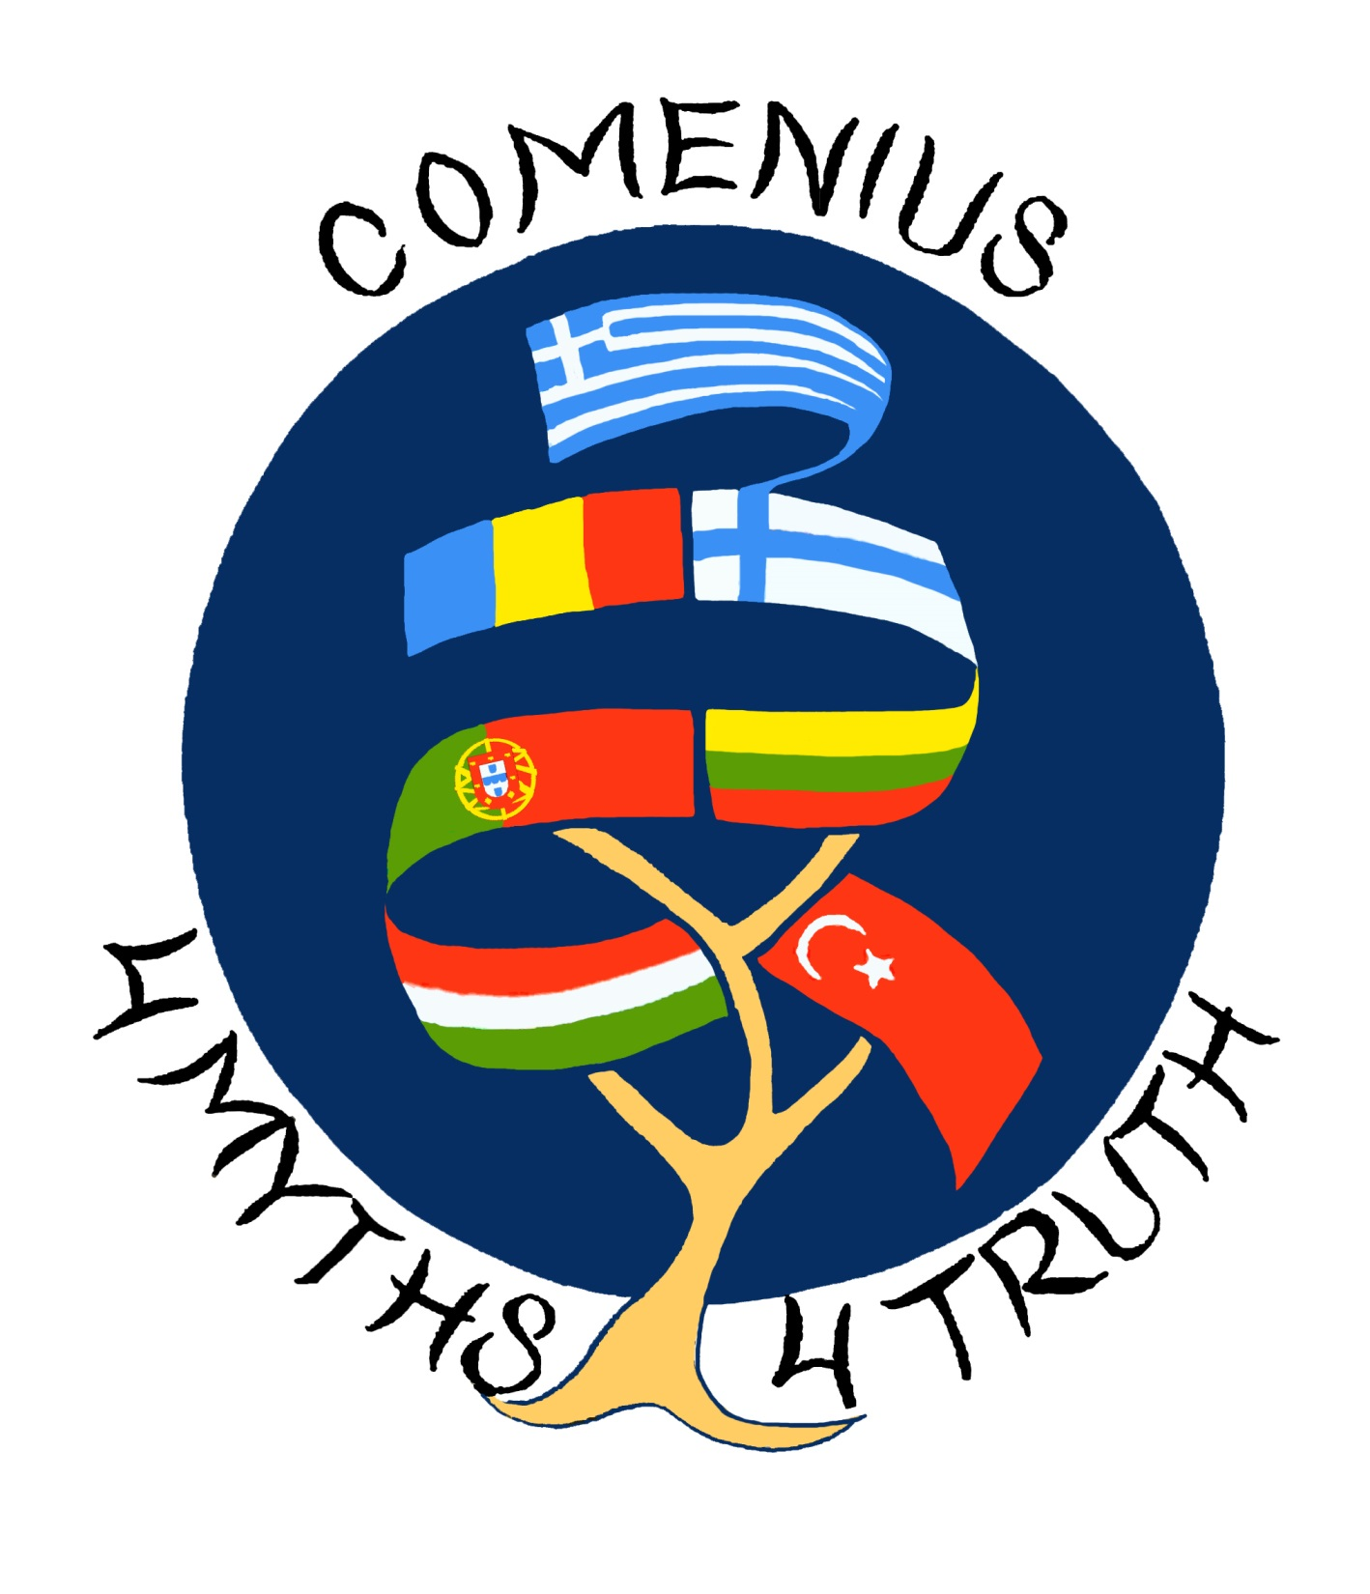


"Through Universal Myths, towards Eternal Truths” 4 Myths 4 Truth
Evaluation Questionnaire Results
Number of students involved in this survey: ………50………
1.
 | Number  of options |  | Number  of options |  | Number  of options
interculturality | 5 | unity | 14 | diversity | 7
dialogue | 28 | sharing | 18 | citizenship | 21
partnership | 29 | common values | 17 | solidarity | 4

2.
 | Number of options
More acceptance of differences | 19
Cultural enrichment | 39
Sharing ideas and knowledge | 33
Preserving national culture | 7
Improvement of linguistic and digital skills | 11
Promotion of values as a support of an active, critical and responsible citizenship | 26
3. Fill in the number of options for each item/column:
 | Not applicable | No impact | Small impact | Medium impact | High impact | Very high impact
Increased language skills |  |  | 9 | 24 | 9 | 8
Increased ICT skills | 3 | 3 | 7 | 24 | 6 | 7
Increased social skills | 2 |  | 5 |  | 10 | 29
Increased motivation | 1 |  | 2 | 6 | 16 | 32
Increased self-esteem |  | 1 | 2 | 9 | 9 | 27
Increased knowledge about partner educational systems | 1 |  | 3 | 15 | 9 | 18
Increased knowledge about partner countries and cultures | 1 | 1 | 4 | 5 | 12 | 23
If other, please specify

4.
 | Number of options
Language | 17
Working in different groups | 32
Staying in a family during the meeting abroad | 25
Too much time dedicated to the project activities | 19
Lack of interest in the carried out activities | 8
5.
 | Number of options
Assigning specific hours in your timetable for the project | 6
A better distribution of tasks | 10
More information about host families before the meeting | 10
Less extracurricular activities for the students, members of the project team | 19
The possibility of choosing the work group according to the individual skills and personal compatibilities | 18
A better selection of the students, project team members, regarding linguistic competences | 13
6. Fill in the number of options for each item/column:
 | 1 | 2 | 3 | 4 | 5
How much did you learn from this Comenius project? |  |  |  | 15 | 35
How much did you enjoy this Comenius project? |  |  |  | 4 | 46

